ASSIGNMENT 1A

Task 1:

Step 1: choose AMI : Amazon Linux 2 AMI(HVM), SSD Volume Type

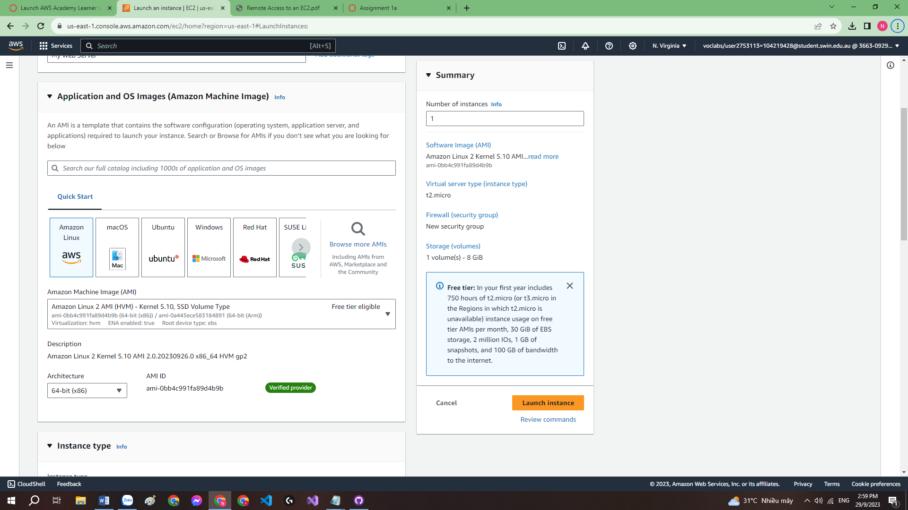

Step 2: Instance stype choose: t2.micro

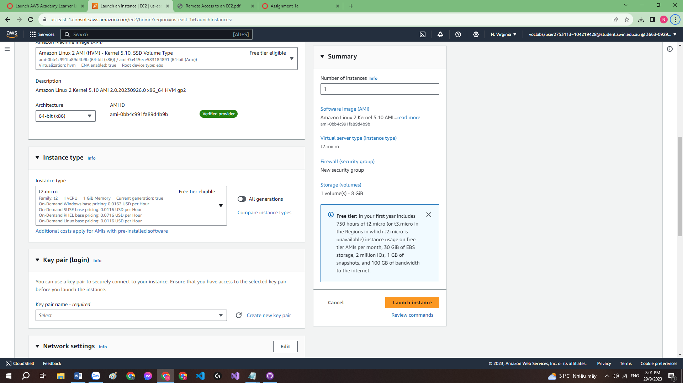

Step 3: Use EC2 setyp script in the Advance detail – User data

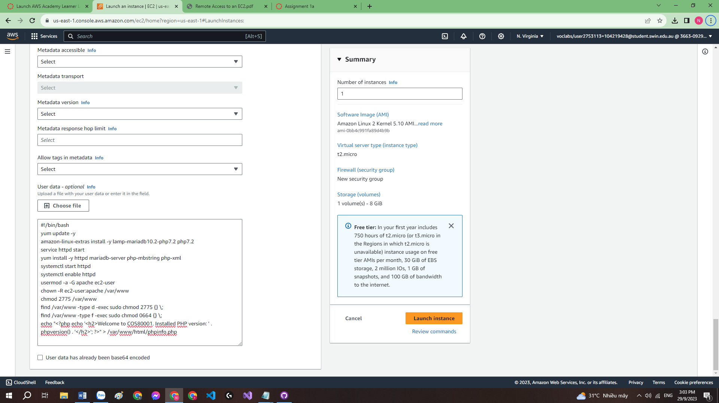

Step 4: New security group. I left it all anywhere to avoid error I don’t understand and configure it later on if required

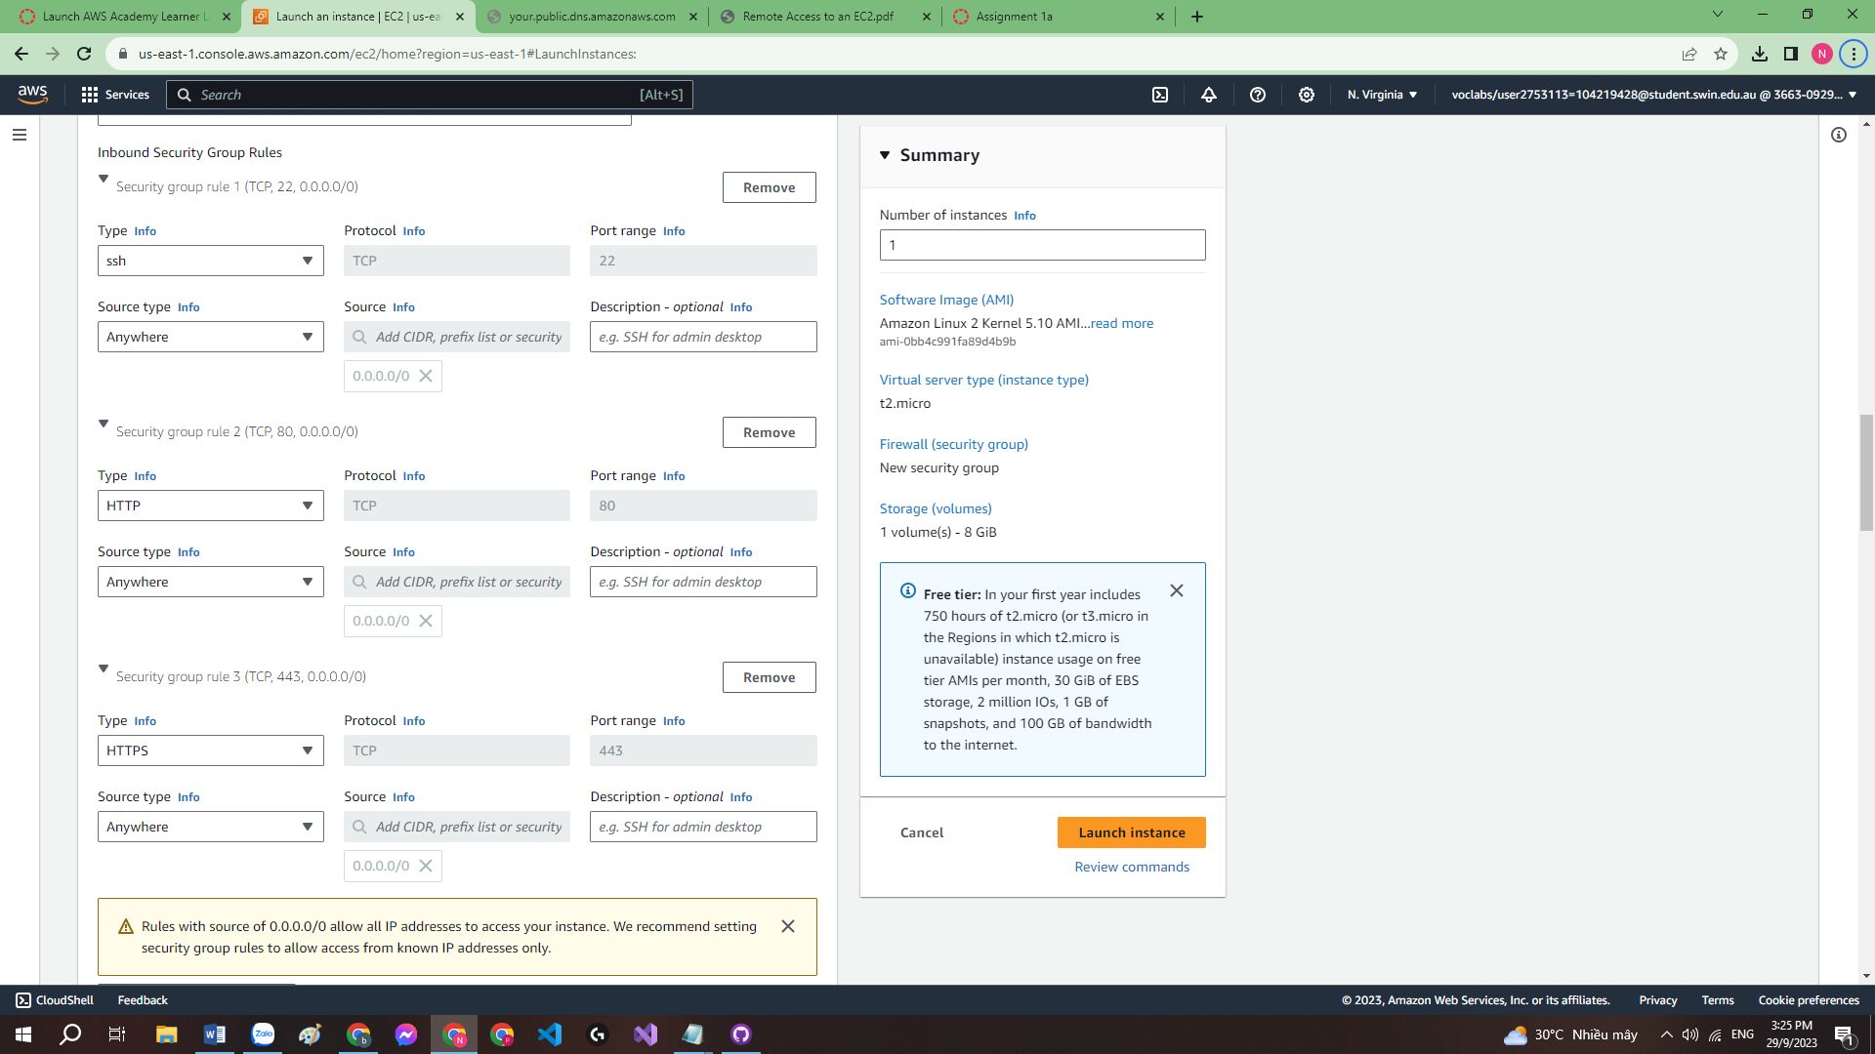

Step 5: create key pairs for remote access.

I forgot to take the screenshot but it goes like this. Name: assignment1a, type: rsa, .ppk file. After created this, my computer automatically download a .ppk file

Step 6: Instance lauched successfully

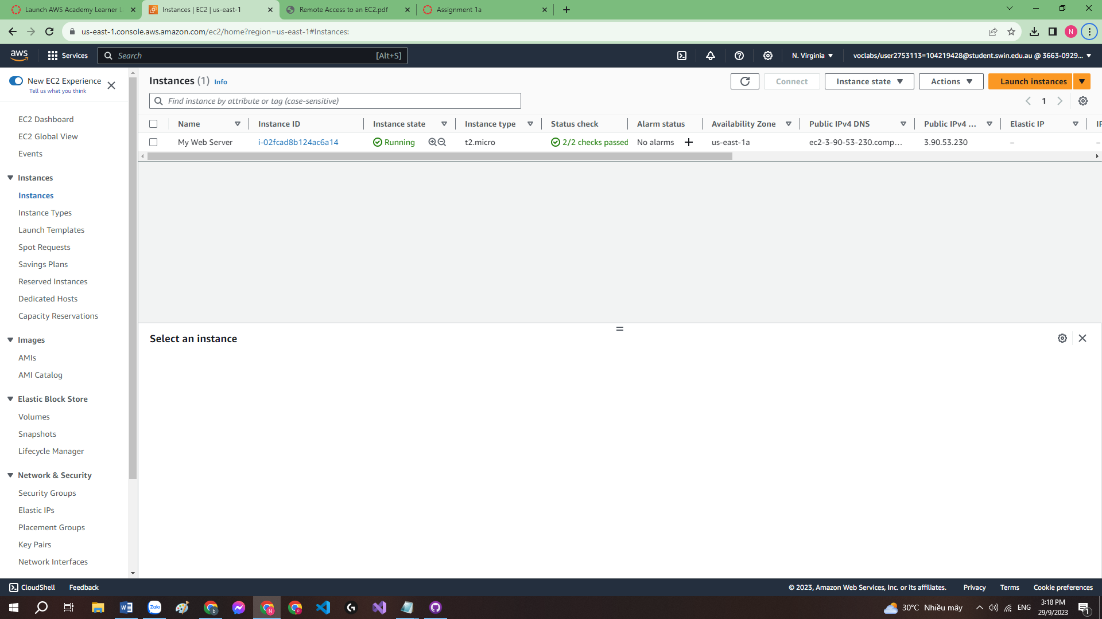

I suffer so much on this (like an hour or something) by not actually using my ec2 public DNS but the one given in the pdf and got unaccessible error T-T.

After looking at the pdf carefully I copy my public DNS from the instance detail and run it:

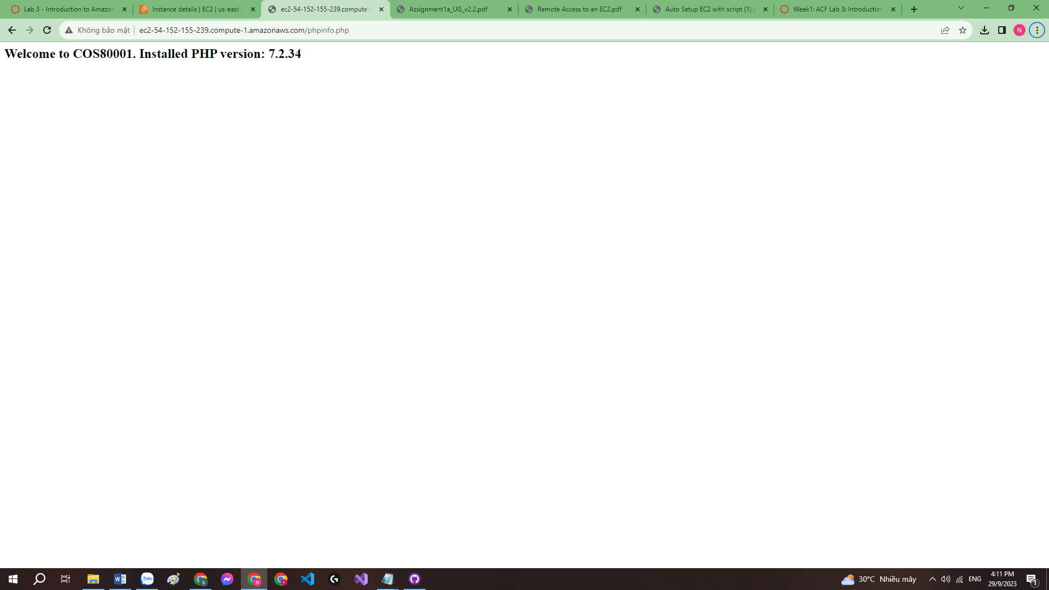

Task 2:

Step 1: Enter WinSCP using my public DNS in instance detail

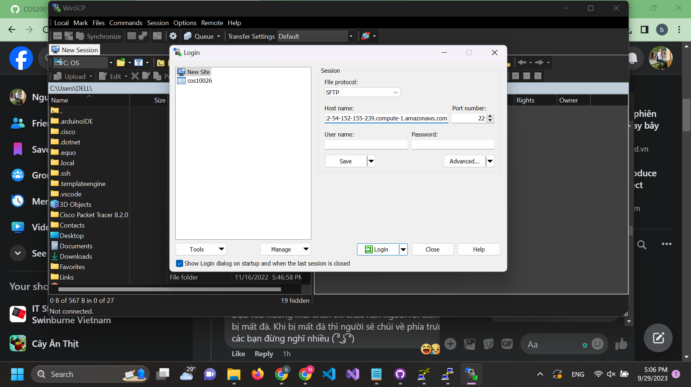

Step 1.2: Navigate to this location and use the private key my computer downloaded when creating the key pair of EC2 instance

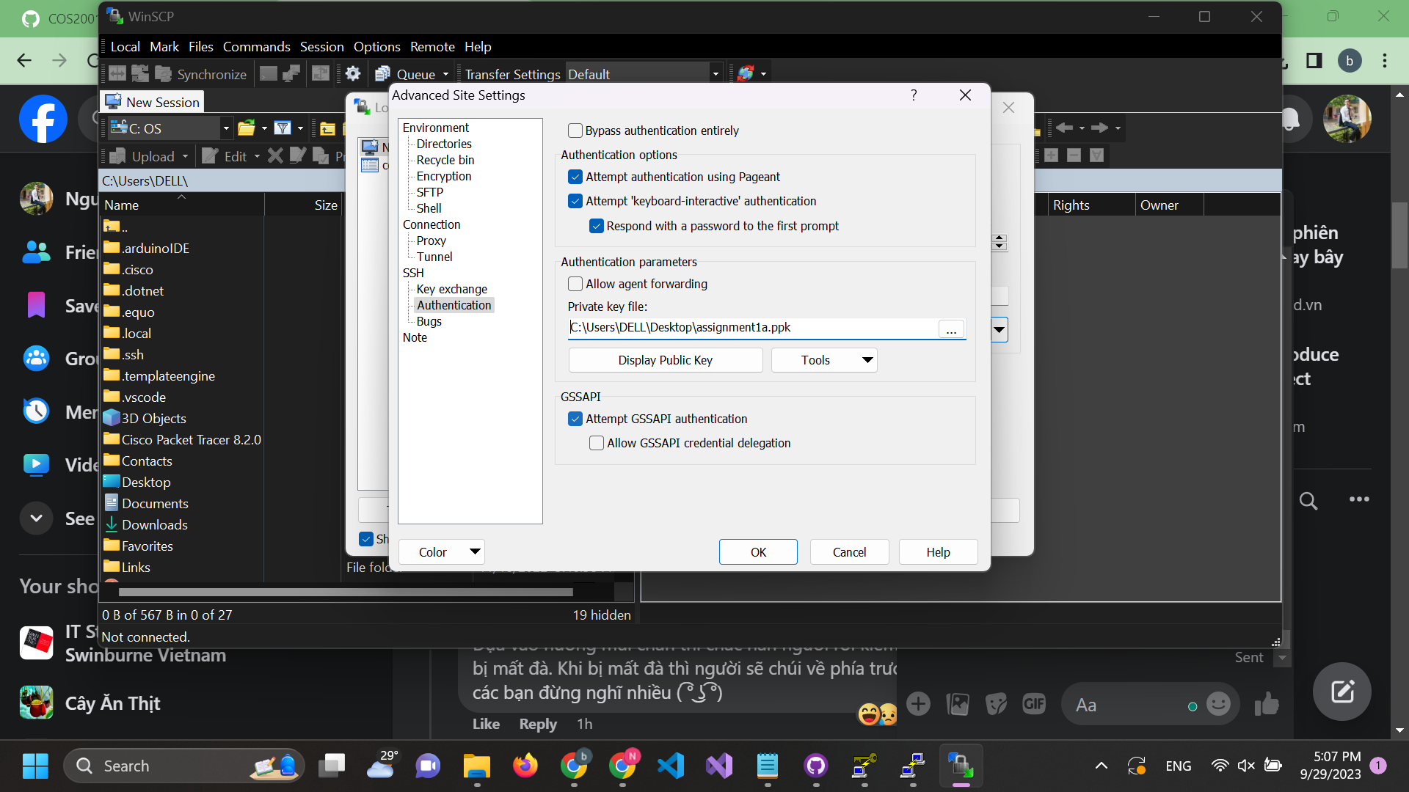

Step 1.3 : Login

Step 2: Create photouploader.php and photolookup.php

In this state I got desvastated as I created it in the wrong location

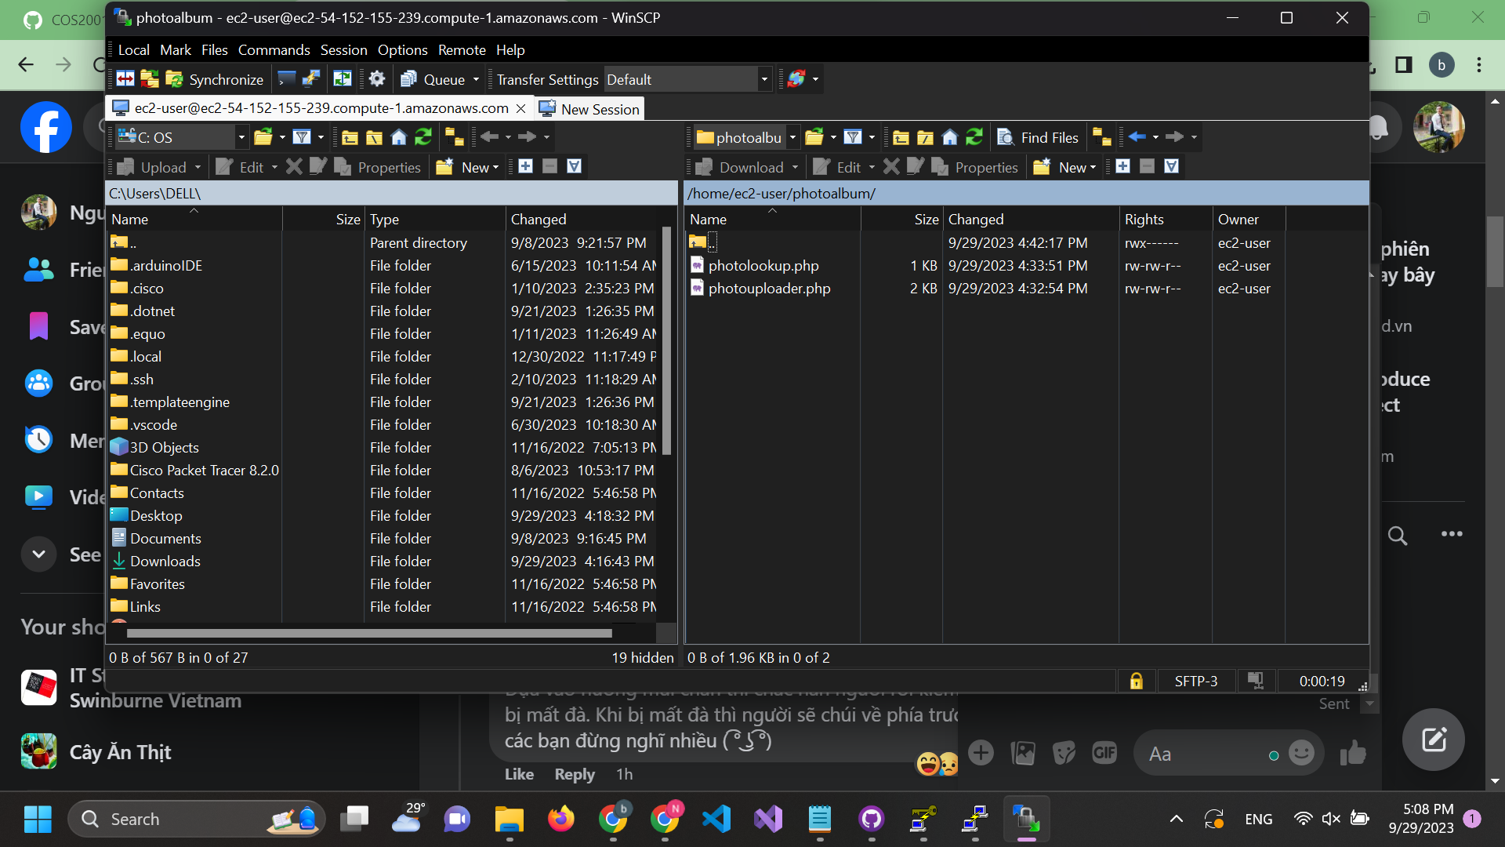

Here is the correct location after like an hour of suffering.

NOTE: the direction is in the pdf T-T

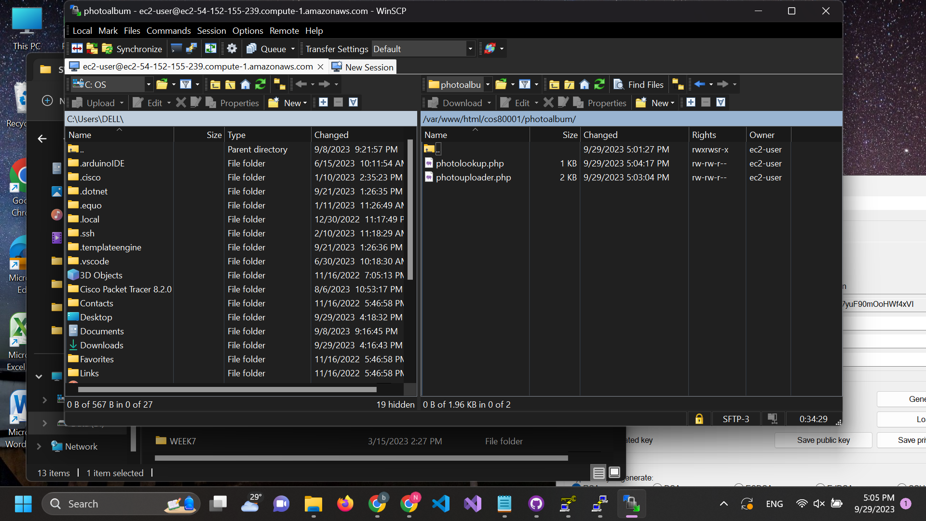

Step 3: Run it

